How to get your SSID for the Bot (For this example I will use Chrome screenshots, however it works exactly the same on edge)

- Login to pocket options on your browser (chrome or edge)
- Navigate to Demo or Real account which ever you’d like to use it on
- Press CTRL + SHIFT + I on your keyboard to bring up the inspection tab
  - 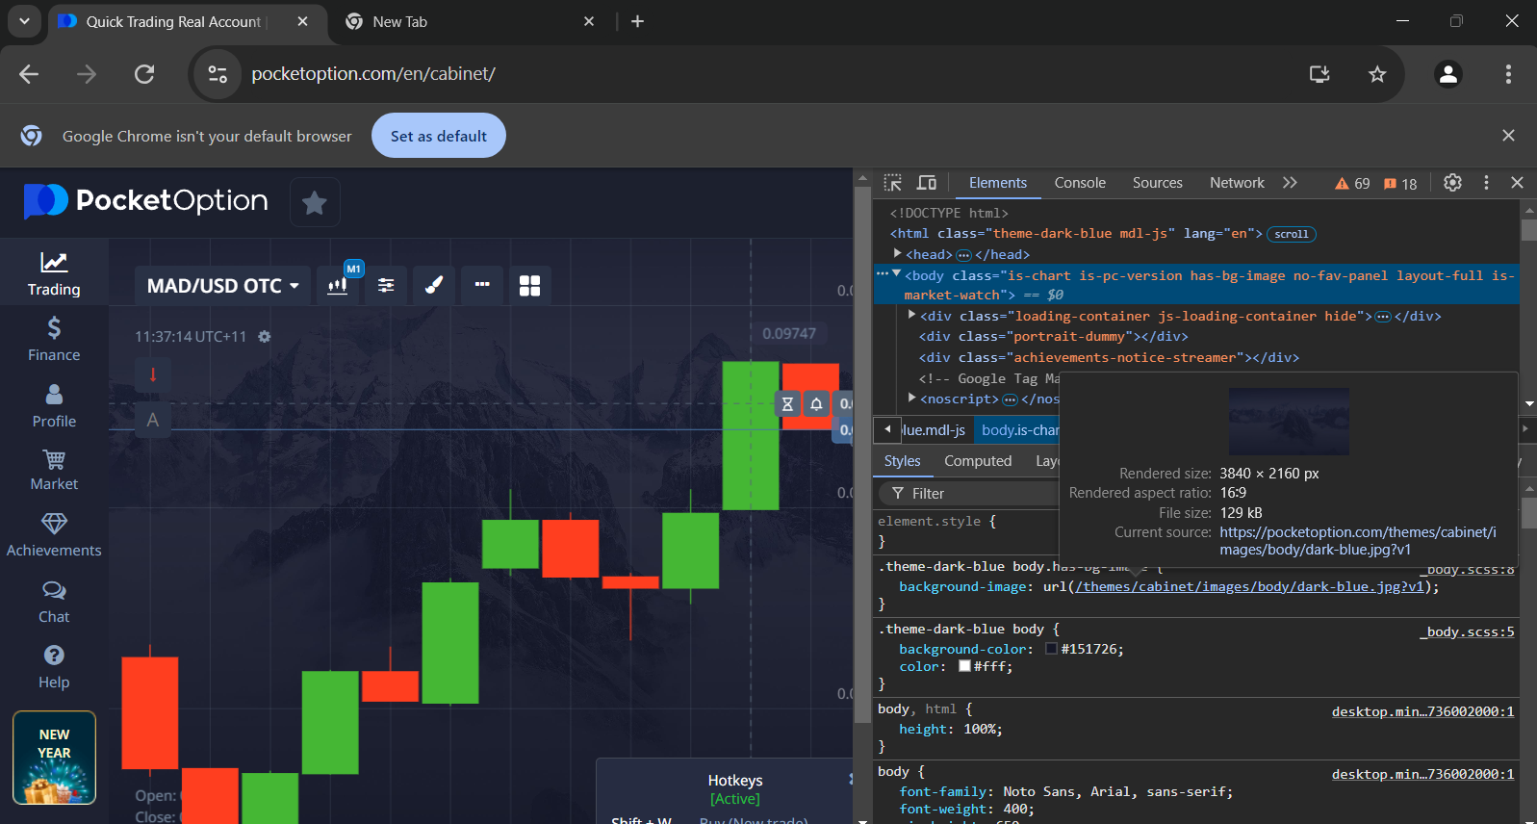
- Click on Network in the console tab
- Then Click on the “WS” box in the network tab
- Once you have clicked the WS box refresh your page
- You will see a bunch of lines populate
  - 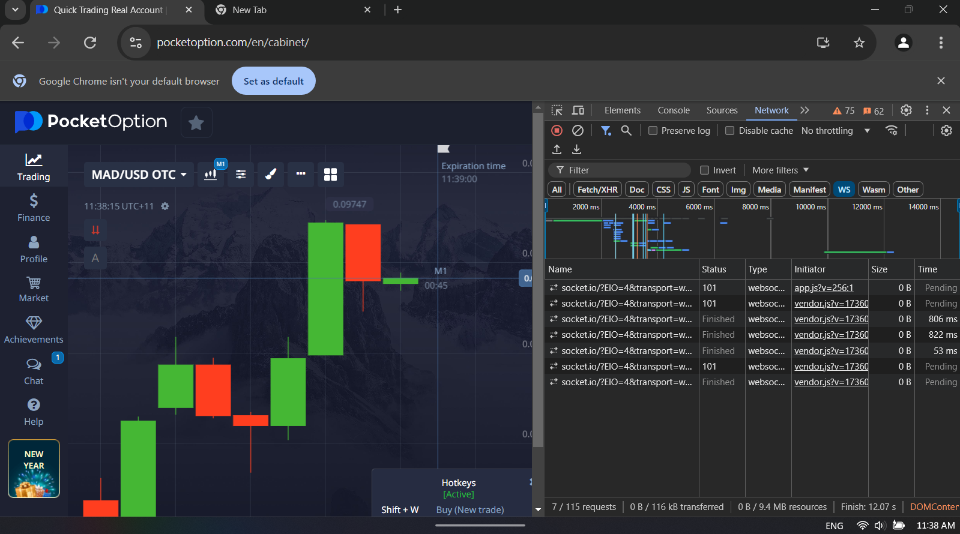
- Search for the Socket connection that has and “AUTH” line. Note it should say “session” not “sessionToken”
  - 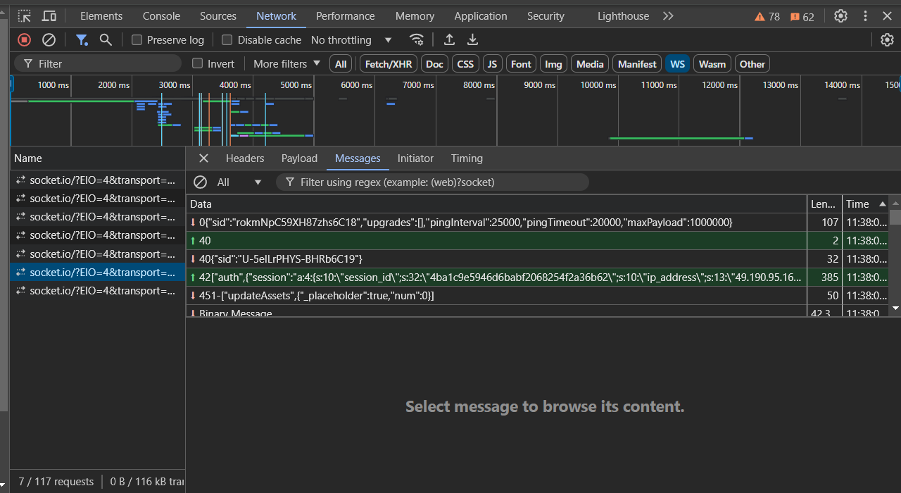
- Right click the AUTH message and click copy message
  - 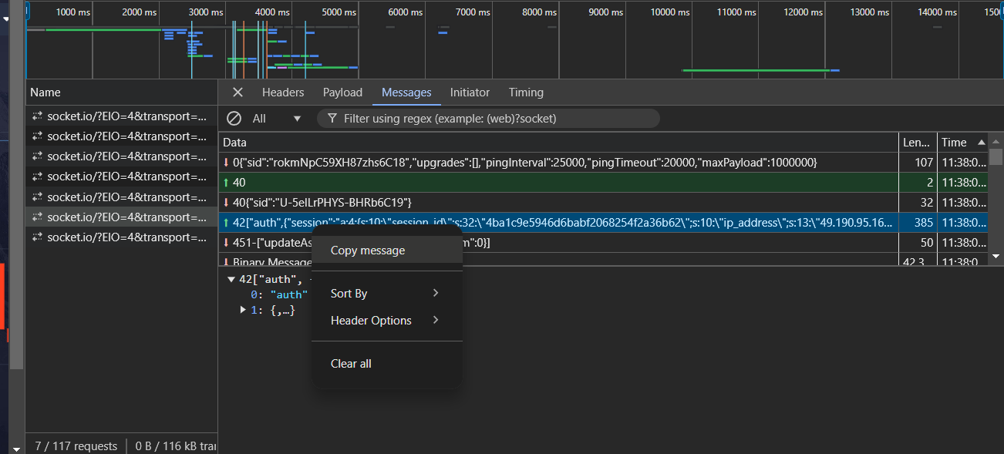
- You have now successfully retrieved your SSID to paste into the bot
  - 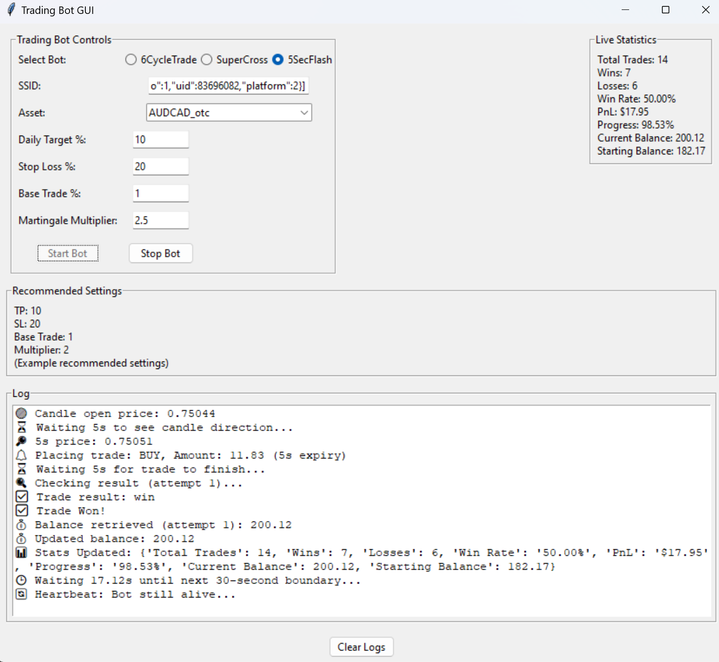
- You will have to do this process each time you login to a new instance of Pocket option

